**Lesson05 Understanding AZ security Groups**

**Notes: -**

**1-NSG (network security group) is attached with Azure VM within Network card , that you can add inbound roles that allow/deny access ports to Azure VM**

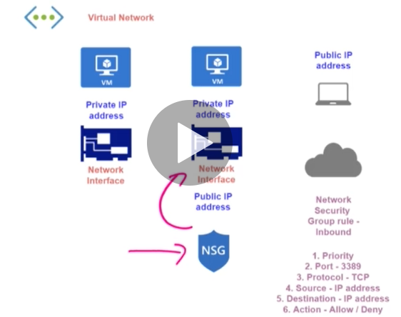

**2-NSG (network security group):- is set of inbound / outbound / load balancer roles**

**That used to set access roles to allow / deny Azure VM**

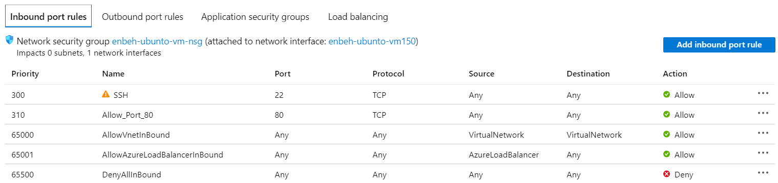

**3-we see that the NSG is connected with public IP address , and with private IP address with the Azure VM**

**(so when you browser the link like** [**http://137.117.152.42/**](http://137.117.152.42/) **,it will check for inbound roles for port 80 roles (by default is denied) ,so you have to add new inbound role on port 80 ,if it allowed it will connect with the AZ VM with the private IP address and show the result)**

**4-the priority of inbound roles between 100 and above , if the number is near from 100 the priority is high and overwrite that the other inbound roles**